Little SPARK: Simple Play Adaptations to Reference for Kids

Tote with Clear Pocket Pages
Description: | Image:
Tote with Clear Pocket Pages consists of six, 9” x 6” usable surfaces made of clear vinyl pocket pages. The outside (cover) of the tote is made of waterproof nylon with webbing handle and tab hook/loop closures for easy open/close. | 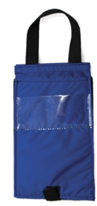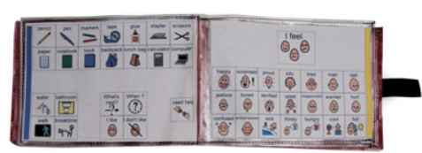  Purchasing Information

Who Might Benefit?
Those who need symbol support and a means of transporting their communication support to express and receive information at any given time.
Why Use?
Provides an opportunity to communicate on-the-go with a variety of communication symbols.
Instructions for Use: | Adaptation Ideas:
Environmental Considerations  - Use in any environment and on the go.  Positioning & Alternate Positioning  - Use in any position or attach to a slant board.  Basic Play/Use  - Introduce a symbol/visual support page, explain what it is and how it is used, and be consistent and make sure it is accessible.  Extended Play/Use  - Model use of the pages within the tote. | Build It Up  - Build up handle for easy gripping or to provide high contrast.  Simplify It  - Introduce a few visuals at a time and/or organize by attribute.  Stabilize It  - Velcro to most surfaces.  Add Sensory Cues  - Add contrasting backgrounds, high contrast visuals, or tab/color code pages.  Alternative Uses  - Use to display schedules, task sequences, etc.

DIY Alternatives
Create a wearable communication notebook from a 3-ring binder (3-ring binders come in a variety of sizes) and add a carrying strap.
  - Cut and laminate various colored tabbed file folders
  - Add strips of Velcro for attaching visuals
  - Punch holes in pages and insert into notebooks
  - Label tabs.
Purchase double sided trading card collector sleeves (9 pockets to standard notebook sized sheets) and insert visuals into pockets. Place sheets in standard 3 ring binder.

